Elham Mahammdi First Assignment

**What is Web**

**Web or WWW (World Wide Web)** the Common name of WWW is Web and it is collection of code page, every Web contain of Videos, Images, Content and etc…

For using the Web, we should have Internet and User sent request to browser and see the Web page.

Web Page

User

Browser

Sample Diagram for request the User in Frontend (1)

In upper Diagram user see how a web work but it more complex than this, there is steps to response the request.

But before we should know some idiom,

1. **DNS** it stands for **Domain Name System** , people access to the internet information with DNS, it is the Internet Phone Book, DNS are [www.google.come](http://www.google.come) or [www.Stackoverflow.com](http://www.Stackoverflow.com). IP (Internet Protocol) a unique string of characters that identifies each computer using the Internet Protocol to communicate over a network. And because IP in hard to use for people, they use DNS
2. **Request**: a web request is use to communicate Client, Browser and Server ,help to find exact page and show in User interface (UI)

1. **Response:** or also called HTTP, what is server send for Client is Response.

Server Side

Browser

Client Side

Request

Response

Request and Response Diagrams (.2)

**4: Client:**  is In User Side and in send request to server side, it is application which is use to communication to server side.

**5: Server:** is a hardware and software which respond to Client with HTTP in the over the world

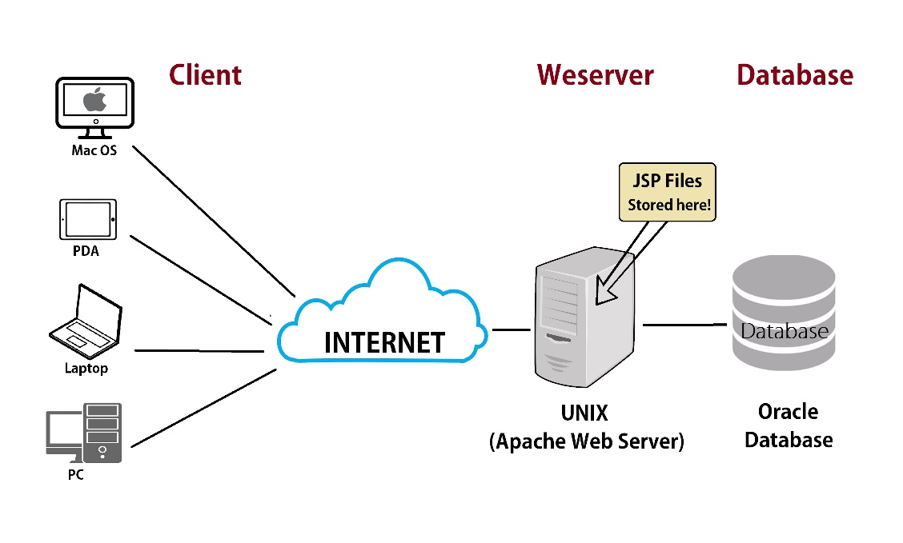

Client and Server Diagram (1.3)

Source : <https://informationq.com/what-is-a-web-server/>

**6: HTML (Hyper *Text Markup Language***)

It is markup language and it use to create web pages’ structure, and it’s Contain of elements and tags

And elements describe to how show the content in browser, the main elements are (HTML, Head, body, P)

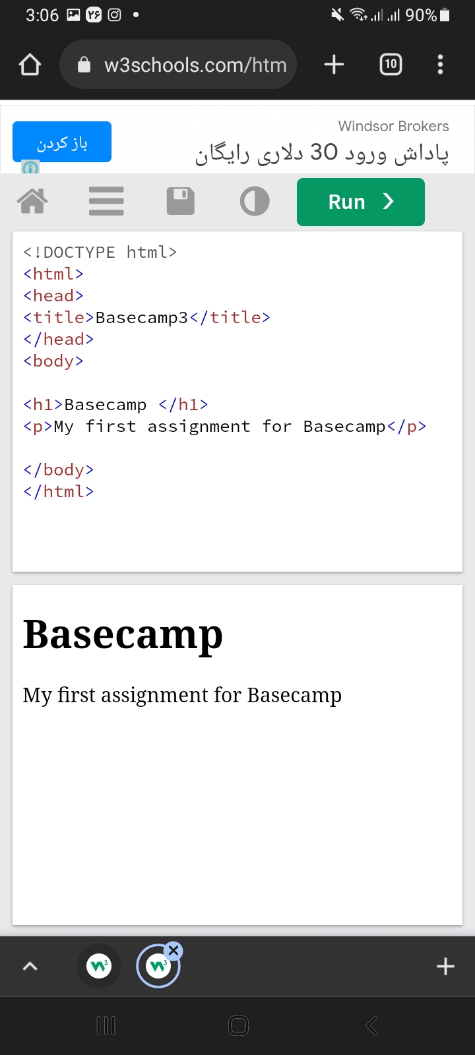

**7: CSS Cascading Style Sheets**

It uses to style our HTML documents and, Give our web page some style

We can display multiple style sheet in our HTML documents and design it and is used to give our website its style. Fonts, colors, sizes, spacing, borders, backgrounds, and shadows are just a few examples of what can be adjusted using CSS.

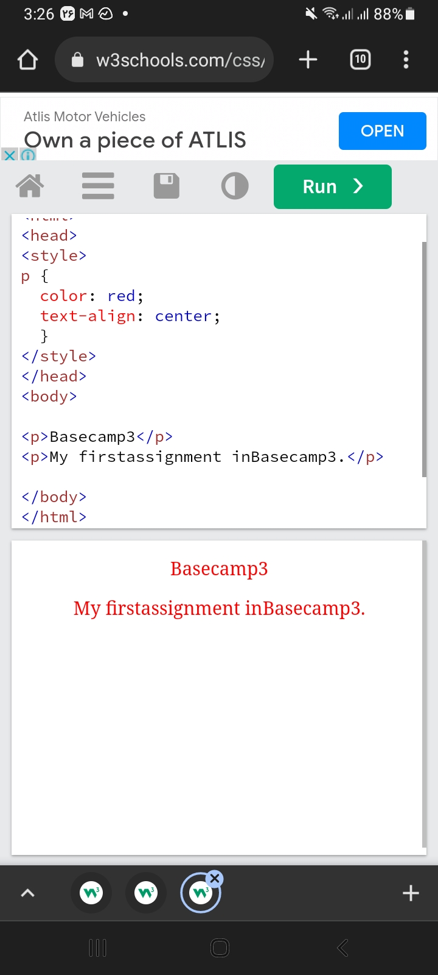

**How Web dose work?**

After we know the all definition about the web main item

Now we define how web work

1. user type a URL in the browser



2. the browser parse the information which in URL, include the domain name and protocols,

3.the browser communicates with your ISP to do a DNS lookup of the IP address for the web server that hosts [www.mail.google.com](http://www.mail.google.com)

4. then the DNS change to the IP address and Once the ISP receives the IP address of the destination server, it sends it to our web browser

5. [our browser takes the IP address and the given port number from the URL and web server are finally connected.](http://preethikasireddy.me/wp-content/uploads/2015/12/Screen-Shot-2015-12-06-at-6.32.27-PM1.png)

6. our web browser sends an HTTP request to the web server for the main HTML web page of  [www.mail.google.com](http://www.mail.google.com)

7. The web server receives the request and looks for that HTML page.

8) our web browser takes the HTML page it receives and then parses through it doing a full head to toe scan looking for other assets that are listed, such as images, CSS files, JavaScript files.

9) For each asset listed, the browser repeats the entire process above, making additional HTTP requests to the server for each resource.

10) Once the browser has finished loading all other assets that were listed in the HTML page, the page will finally be loaded in the browser window and the connection will be closed

DNS IP Address

User

ISP change

Server

IP Address

[www.mail.google.com](http://www.mail.google.com)

HTML, JS, CSS, pictures

Code

HTTP